Healy WecSim Model Workflow

1. Center of mass, moments of inertia from Glenn
   1. Center of submerged volume is 0.35 m *below* center of gravity. 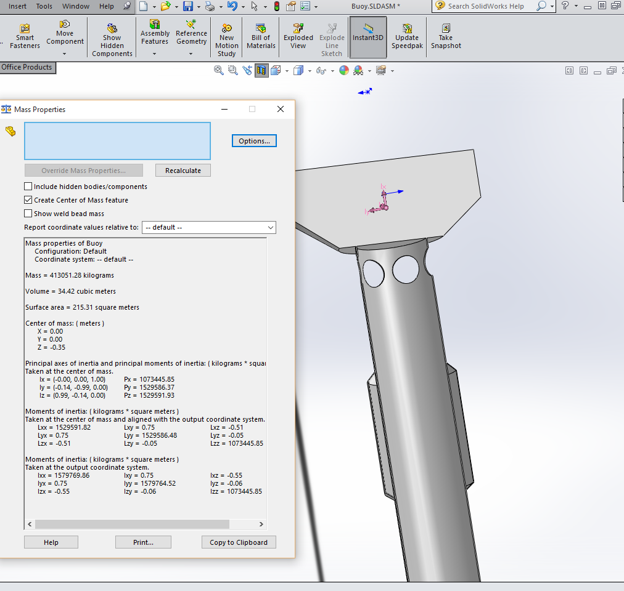
   2. CG wasn’t updated (used -2 m)
      1. CG is wtrln=-(120-48)*0.0254= -1.8288 from top
2. Hydro coefficients from Nemoh.
   1. Nea_mesh2.m. Body 2 is tiny disk ~~version of larger HWEC (temporary hack).~~
   2. ~~Ran first section twice to get two sets of hydrostatics from Mesh.exe (manually named KH_01, KH_02).~~
3. Ran bemio (no scale argument—default is False).
4. Copied .h5 to RM3Healy folder.
5. Modified manually in HDF5 Viewer:
   1. Body 2
      1. Disp_vol
      2. CG –CHECK
      3. CB—Check (equal to CG)
   2. Body 1
      1. Disp_vol=37.8283
      3. CB=-1 --------Need to change Restoring moment accordingly‼? (But how is it unscaled [i.e. nondimensionalized]? ~~Probably by rho.~~ Scaled by rho*g.